**Install TestNG plugin IntelliJ**: (**Pre-requisite**)

1. Go to Settings –> Plugins
2. Wait for popup to be opened and loaded with options in it.

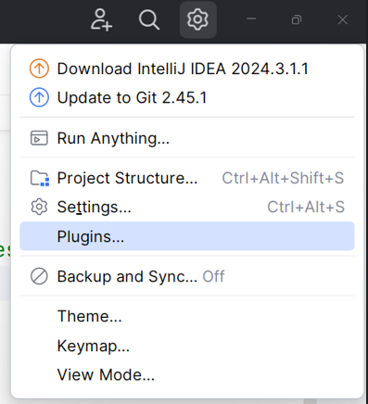

1. Search for **TestNG** in it

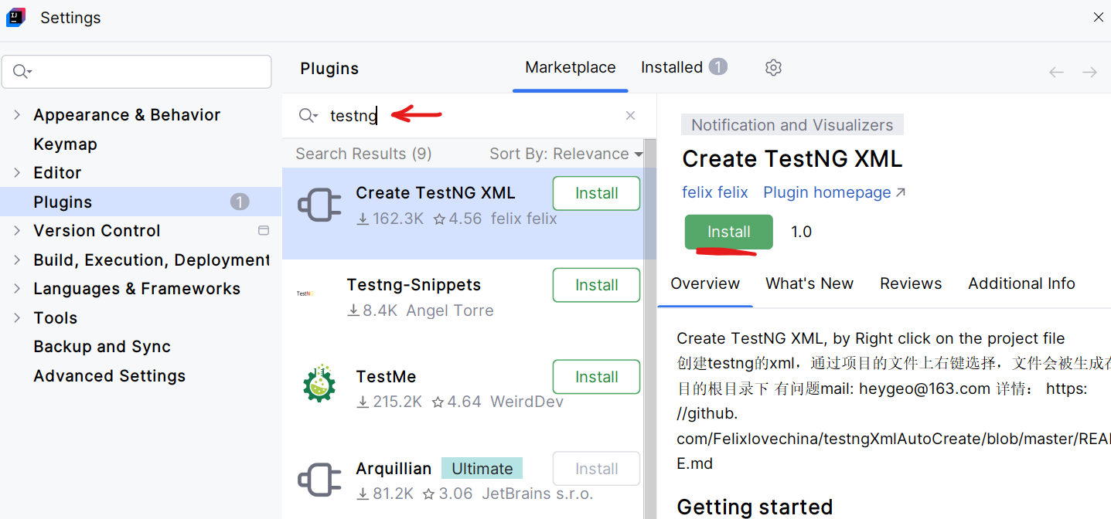

1. Click on **Install** button of ‘Create TestNG XML’ option/plugin
2. Once installed, click on **apply** button.
3. **Restart** the IntelliJ
4. Right click on Project**/**package**/**class

* If right click on **project**, then ‘all testNG classes from that project’ will be considered for suite file.
* If right click on **package**, then ‘all testNG from that package will be considered for suite file.
* If right click on **class**, then ‘all testNG TC from that class will be considered for suite file.

1. Click on **Create TestNG XML** file option
2. It will open one popup showing the suite file creation path and its name as **testng.xml**.
3. **testng.xml** file will be created at project location; we can rename it as per our requirement. E.g. Regression_suite.xml, smoke_suite.xml, …

* Write syntax of suite.xml file:

<suite name=”Regression Test Cases” …

<test name=”UAT Environment” …

<classes …

<class name = “package_name.className”></class>

<class …

<class …

…

</classes>

</test>

</suite>

* **Note**: As per next testng topics, we are going to update this syntax.